Packages
Packages and Imports are Java's system for organizing code file folders and accessing tools.
Think of a large computer. You do not throw every single picture, document, and song onto your desktop. You organize them into folders like /Images or /Music.
- Packages are the folders used to group related Java files together.
- Rules for Packages:
    - The Declaration: If a file belongs in a package folder, the very first line of code must state that package name.
  - Naming Convention: Package names are always completely lowercase. Large companies use their reversed website domain to make them unique (e.g., com.apple.shapes)
- Example of a Package File:
Imagine you create a folder named geometry. Inside it, you make a file named Circle.java. The code looks like this:

package geometry; // 1. Declares that this file lives in the geometry folder
public class Circle {
public double calculateArea(double radius) {
return 3.14 * radius * radius;
}
}
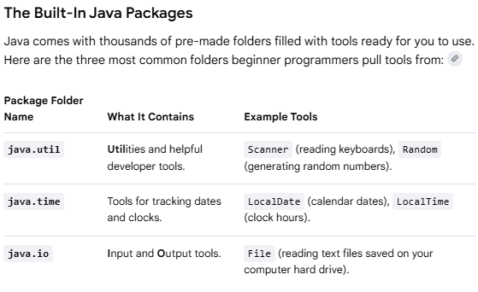

imports
If you want to use that Circle tool inside a completely different project folder, your main program will not be able to find it automatically. You must import it to bridge the gap.
- import keyword is used to bring pre-written code libraries into your program from massive Java digital libraries.
- By default Java only loads a tiny handful of essential libraries (like basic math and text strings) so your program stays lightweight and fast.
- Place import statements at the very top of your code file, before your class even begins.
- Importing Your Custom Package:
import geometry.Circle; // 1. Pulls the Circle tool out of the geometry folder
public class MainProgram {
public static void main(String[] args) {

Circle myShape = new Circle(); // 2. Now you can use it freely!

}
}
